1)Creating Scrum project in Jira

2)Select company managed project

3)Give a Project name

4)Create version

5)Create epic

6)Create user stories

7)Start the sprint

8)Import the testcases

9)Testcases will be present in Test Cases( zephyr squad -> Test Cases)

10)Create test cycle

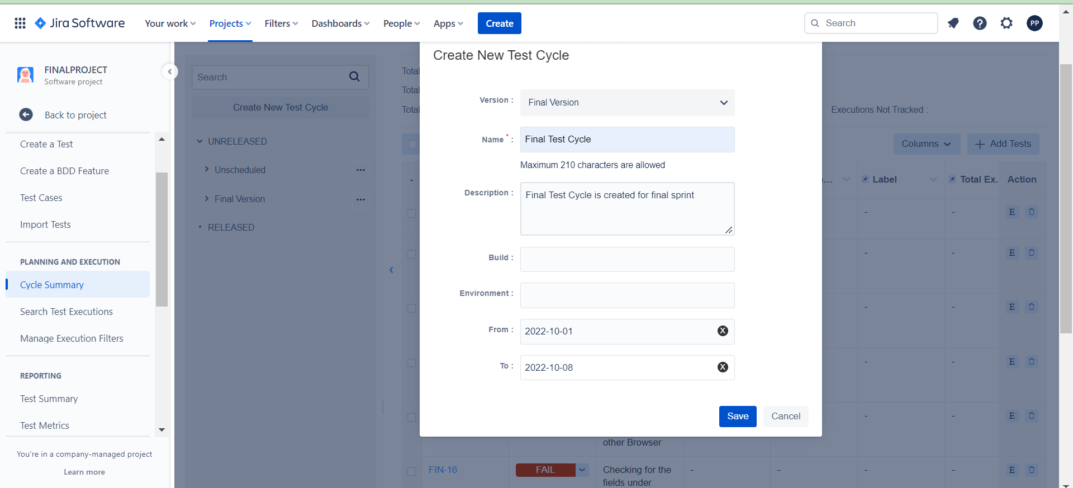

11)Add test cases to test cycle

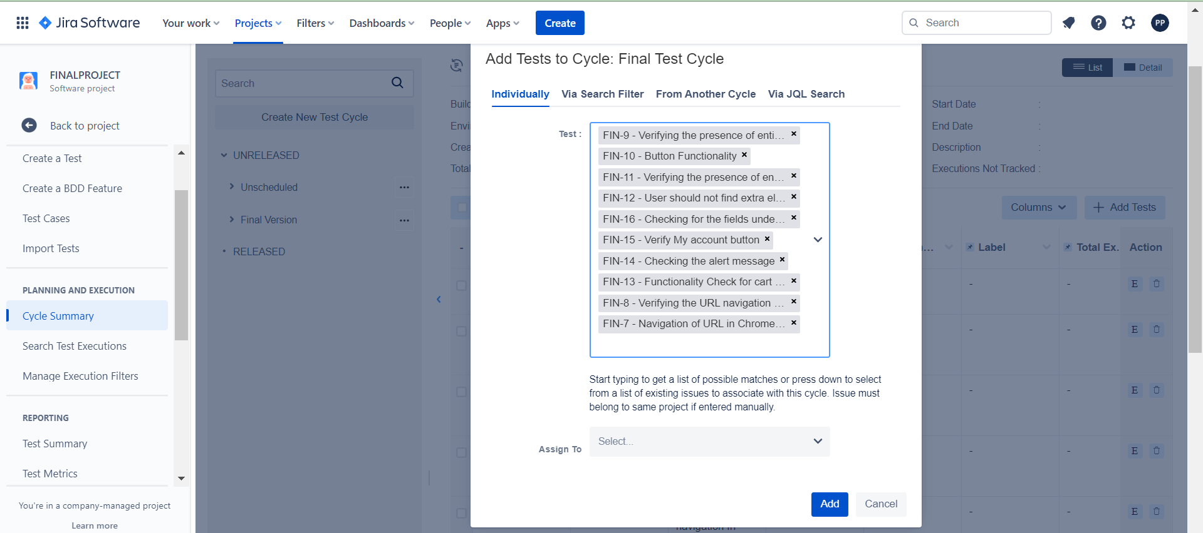

12)Execute the test cases

13)Bug is created and assigned to developer

